**Build a decision tree for the ‘iris’ data with function ‘ctree()’ in package “party”.**

**Ans:**

>install.packages("party")

> library(party)

> data("iris")

> View(iris)

> head(iris)

Sepal.Length Sepal.Width Petal.Length Petal.Width Species

1 5.1 3.5 1.4 0.2 setosa

2 4.9 3.0 1.4 0.2 setosa

3 4.7 3.2 1.3 0.2 setosa

4 4.6 3.1 1.5 0.2 setosa

5 5.0 3.6 1.4 0.2 setosa

6 5.4 3.9 1.7 0.4 setosa

**Some of the useful Information from help command for “ctree” Function from “party” library**

> help("ctree")

Description

Recursive partitioning for continuous, censored, ordered, nominal and multivariate response variables in a conditional inference framework.

Usage

ctree(formula, data, subset = NULL, weights = NULL,

controls = ctree_control(), xtrafo = ptrafo, ytrafo = ptrafo,

scores = NULL)

Details

Conditional inference trees estimate a regression relationship by binary recursive partitioning in a conditional inference framework. Roughly, the algorithm works as follows: 1) Test the global null hypothesis of independence between any of the input variables and the response (which may be multivariate as well). Stop if this hypothesis cannot be rejected. Otherwise select the input variable with strongest association to the resonse. This association is measured by a p-value corresponding to a test for the partial null hypothesis of a single input variable and the response. 2) Implement a binary split in the selected input variable. 3) Recursively repeate steps 1) and 2).

**So Building model based on above information and syntax.**

> irisct <- ctree(Species ~ .,data = iris)

> irisct

Conditional inference tree with 4 terminal nodes

Response: Species

Inputs: Sepal.Length, Sepal.Width, Petal.Length, Petal.Width

Number of observations: 150

1) Petal.Length <= 1.9; criterion = 1, statistic = 140.264

2)* weights = 50

1) Petal.Length > 1.9

3) Petal.Width <= 1.7; criterion = 1, statistic = 67.894

4) Petal.Length <= 4.8; criterion = 0.999, statistic = 13.865

5)* weights = 46

4) Petal.Length > 4.8

6)* weights = 8

3) Petal.Width > 1.7

7)* weights = 46

> plot(irisct)

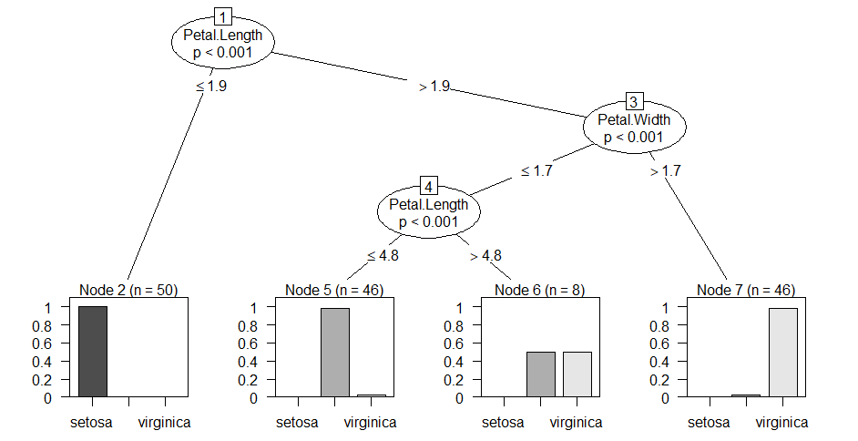

> table(predict(irisct), iris$Species)

setosa versicolor virginica

setosa 50 0 0

versicolor 0 49 5

virginica 0 1 45

> CrossTable(iris$Species,pred_iris)

Cell Contents

|-------------------------|

| N |

| Chi-square contribution |

| N / Row Total |

| N / Col Total |

| N / Table Total |

|-------------------------|

Total Observations in Table: 150

| pred_iris

iris$Species | setosa | versicolor | virginica | Row Total |

-------------|------------|------------|------------|------------|

setosa | 50 | 0 | 0 | 50 |

| 66.667 | 18.000 | 15.333 | |

| 1.000 | 0.000 | 0.000 | 0.333 |

| 1.000 | 0.000 | 0.000 | |

| 0.333 | 0.000 | 0.000 | |

-------------|------------|------------|------------|------------|

versicolor | 0 | 49 | 1 | 50 |

| 16.667 | 53.389 | 13.399 | |

| 0.000 | 0.980 | 0.020 | 0.333 |

| 0.000 | 0.907 | 0.022 | |

| 0.000 | 0.327 | 0.007 | |

-------------|------------|------------|------------|------------|

virginica | 0 | 5 | 45 | 50 |

| 16.667 | 9.389 | 57.399 | |

| 0.000 | 0.100 | 0.900 | 0.333 |

| 0.000 | 0.093 | 0.978 | |

| 0.000 | 0.033 | 0.300 | |

-------------|------------|------------|------------|------------|

Column Total | 50 | 54 | 46 | 150 |

| 0.333 | 0.360 | 0.307 | |

-------------|------------|------------|------------|------------|